Ex.No: 4.a | EDA– DATA INSPECTION, FILTERING, STATISTICAL ANALYSIS AND CORRELATION
Aim:

Algorithm:
Step1: Start.
Step2:Import the required libraries
Step3 Load the dataset into a pandas DataFrame.
Step4 Display the first five rows using df.head().
Step5 Display the shape of the dataset using df.shape.
Step6 Display the data types of each column using df.dtypes.
Step7 Filter records based on a condition (e.g., Marks > 85 or Age > 50).
Step8 Filter records belonging to a specific category (e.g., Department or Disease).
Step9 Sort the dataset using df.sort_values().
Step10 Calculate statistical measures:
- Mean
- Median
- Mode
- Standard Deviation
Step11 Display summary statistics using df.describe().
Step12 Group the data using groupby() and calculate the average.
Step13 Find the correlation between numerical columns using corr().
Step14 Create a Scatter Plot using Matplotlib.
Step15 Create a Bar Plot using Matplotlib.
Step16 Display the graphs.
program:

import pandas as pd
import matplotlib.pyplot as plt

# Create DataFrame
data = {
"Roll No": [101,102,103,104,105,106],
"Name": ["Arun","Bala","Divya","Priya","Ravi","Karthik"],
"Department": ["CSE","IT","CSE","AI&DS","IT","AI&DS"],
"Marks": [85,78,95,90,72,88],
"Attendance": [92,88,96,94,85,91]
}

df = pd.DataFrame(data)

# View Data
print("First 5 Rows")
print(df.head())

print("\nShape")
print(df.shape)

print("\nData Types")
print(df.dtypes)

# Filter Marks > 85
print("\nStudents with Marks > 85")
high_marks = df[df["Marks"] > 85]
print(high_marks)

# Filter IT Department
print("\nIT Department Students")
it_students = df[df["Department"] == "IT"]
print(it_students)

# Sort by Marks
print("\nSorted by Marks")
sorted_df = df.sort_values(by="Marks", ascending=False)
print(sorted_df)

# Statistics
print("\nMean =", df["Marks"].mean())
print("Median =", df["Marks"].median())
print("Mode =")
print(df["Marks"].mode())
print("Standard Deviation =", df["Marks"].std())

# Summary
print("\nSummary Statistics")
print(df.describe())

# Group By
print("\nAverage Marks by Department")
dept_avg = df.groupby("Department")["Marks"].mean()
print(dept_avg)

# Correlation
print("\nCorrelation")
corr = df[["Marks","Attendance"]].corr()
print(corr)

# Scatter Plot
plt.scatter(df["Attendance"], df["Marks"])
plt.title("Marks vs Attendance")
plt.xlabel("Attendance")
plt.ylabel("Marks")
plt.grid(True)
plt.show()

# Bar Plot
dept_avg.plot(kind="bar")
plt.title("Average Marks by Department")
plt.xlabel("Department")
plt.ylabel("Average Marks")
plt.show()
Output:

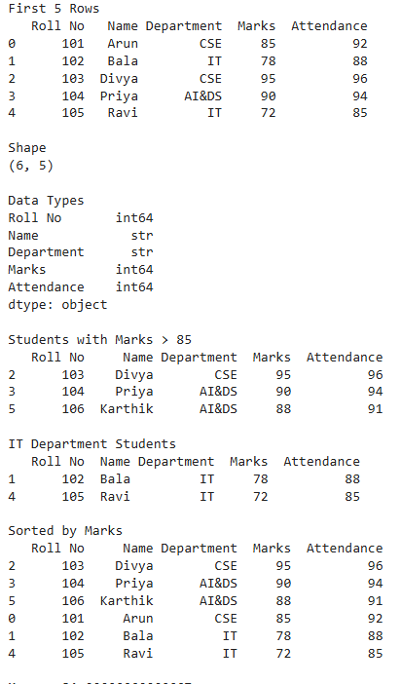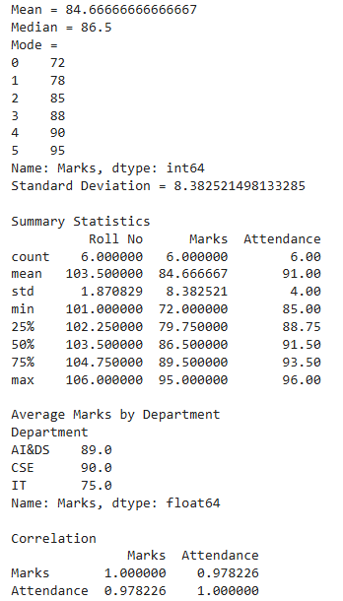
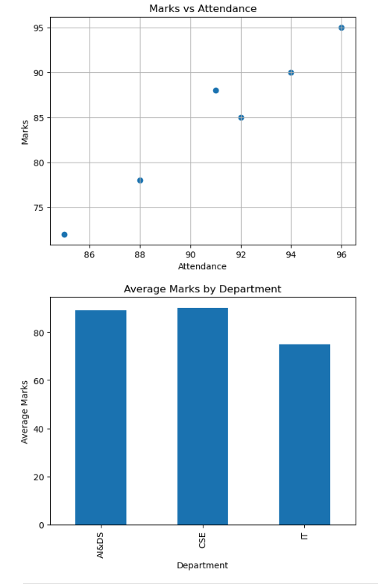

Result:

Ex.No:4.b | EDA– DATA INSPECTION, FILTERING, STATISTICAL ANALYSIS AND CORRELATION
Aim:

Algorithm:
Step1: Start.
Step2:Import the required libraries
Step3 Load the dataset into a pandas DataFrame.
Step4 Display the first five rows using df.head().
Step5 Display the shape of the dataset using df.shape.
Step6 Display the data types of each column using df.dtypes.
Step7 Filter records based on a condition (e.g., Marks > 85 or Age > 50).
Step8 Filter records belonging to a specific category (e.g., Department or Disease).
Step9 Sort the dataset using df.sort_values().
Step10 Calculate statistical measures:
- Mean
- Median
- Mode
- Standard Deviation
Step11 Display summary statistics using df.describe().
Step12 Group the data using groupby() and calculate the average.
Step13 Find the correlation between numerical columns using corr().
Step14 Create a Scatter Plot using Matplotlib.
Step15 Create a Bar Plot using Matplotlib.
Step16 Display the graphs.
Program:
import pandas as pd

df = pd.read_csv(r"C:\Users\HP\Downloads\archive\automobile_dataset.csv")
print("===== FULL DATA =====")
print(df)

print("\n===== HEAD (First 5 Rows) =====")
print(df.head())
print(df.info())

print("\n===== DESCRIBE (Summary Statistics) =====")
print(df.describe())
print("\n===== SHAPE =====")
print(df.shape)
print("\n===== DATA TYPES =====")
print(df.dtypes)
# 3. FILTER COLUMNS
print("\n===== FILTER COLUMNS (Make, Year, Selling_Price) =====")
print(df[["Make", "Year", "Selling_Price"]])

print("\n===== FILTER COLUMNS (Fuel_Type, Body_Type, Mileage) =====")
print(df[["Fuel_Type", "Body_Type", "Mileage"]])
# 4. FILTER ROWS
print("\n===== Year > 2015 =====")
print(df[df["Year"] > 2015])

print("\n===== Fuel_Type = Petrol =====")
print(df[df["Fuel_Type"] == "Petrol"])

print("\n===== Transmission = Automatic =====")
print(df[df["Transmission"] == "Automatic"])

print("\n===== Body_Type = SUV =====")
print(df[df["Body_Type"] == "SUV"])

print("\n===== Accident_History = 1 (Yes) =====")
print(df[df["Accident_History"] == 1])
print("\n===== Year > 2015 AND Transmission = Automatic =====")
print(df[(df["Year"] > 2015) & (df["Transmission"] == "Automatic")])

print("\n===== Mileage > 50000 AND Fuel_Type = Diesel =====")
print(df[(df["Mileage"] > 50000) & (df["Fuel_Type"] == "Diesel")])
# 5. SORTING
print("\n===== SORT BY Year (Ascending) =====")
print(df.sort_values(by="Year"))

print("\n===== SORT BY Year (Descending) =====")
print(df.sort_values(by="Year", ascending=False))

print("\n===== SORT BY Selling_Price (Descending) =====")
print(df.sort_values(by="Selling_Price", ascending=False))

print("\n===== SORT BY Make AND Year =====")
print(df.sort_values(by=["Make", "Year"]))

print("\n===== SORT BY Body_Type AND Mileage =====")
print(df.sort_values(by=["Body_Type", "Mileage"]))
print("\n===== STATISTICS ON Selling_Price =====")
print("Mean Selling_Price =", df["Selling_Price"].mean())
print("Median Selling_Price =", df["Selling_Price"].median())
print("Mode Selling_Price =")
print(df["Selling_Price"].mode())
print("Std Dev Selling_Price =", df["Selling_Price"].std())

print("\n===== STATISTICS ON Mileage =====")
print("Mean Mileage =", df["Mileage"].mean())
print("Median Mileage =", df["Mileage"].median())
print("Std Dev Mileage =", df["Mileage"].std())

print("\n===== STATISTICS ON Year =====")
print("Mean Year =", df["Year"].mean())
print("Median Year =", df["Year"].median())
print("\n===== Average Selling_Price by Fuel_Type =====")
fuel_avg = df.groupby("Fuel_Type")["Selling_Price"].mean()
print(fuel_avg)

print("\n===== Average Selling_Price by Body_Type =====")
body_avg = df.groupby("Body_Type")["Selling_Price"].mean()
print(body_avg)

print("\n===== Average Selling_Price by Make =====")
make_avg = df.groupby("Make")["Selling_Price"].mean().sort_values(ascending=False)
print(make_avg)

print("\n===== Average Mileage by Transmission =====")
print(df.groupby("Transmission")["Mileage"].mean())
print("\n===== CORRELATION (Year vs Selling_Price) =====")
print(df["Year"].corr(df["Selling_Price"]))

print("\n===== CORRELATION (Mileage vs Selling_Price) =====")
print(df["Mileage"].corr(df["Selling_Price"]))

print("\n===== CORRELATION (Engine_Size vs Horsepower) =====")
print(df["Engine_Size"].corr(df["Horsepower"]))

print("\n===== CORRELATION (Horsepower vs Selling_Price) =====")
print(df["Horsepower"].corr(df["Selling_Price"]))

print("\n===== FULL PEARSON CORRELATION (Numeric Columns) =====")
print(df.corr(numeric_only=True, method='pearson'))

print("\n===== FULL SPEARMAN CORRELATION (Numeric Columns) =====")
print(df.corr(numeric_only=True, method='spearman'))

print("\n===== Correlation Matrix (selected columns) =====")
corr = df[["Year", "Mileage", "Engine_Size", "Horsepower", "Selling_Price"]].corr()
print(corr)
import matplotlib.pyplot as plt

plt.figure(figsize=(7, 5))
plt.scatter(df["Mileage"], df["Selling_Price"], alpha=0.5)
plt.title("Mileage vs Selling Price")
plt.xlabel("Mileage")
plt.ylabel("Selling Price")
plt.grid(True)
plt.tight_layout()
plt.show()

# Scatter Plot 2: Year vs Selling_Price
plt.figure(figsize=(7, 5))
plt.scatter(df["Year"], df["Selling_Price"], alpha=0.5, color="green")
plt.title("Year vs Selling Price")
plt.xlabel("Year")
plt.ylabel("Selling Price")
plt.grid(True)
plt.tight_layout()
plt.show()

# Bar Plot 1: Average Selling Price by Fuel_Type
fuel_avg.plot(kind="bar", color="skyblue", edgecolor="black")
plt.title("Average Selling Price by Fuel Type")
plt.xlabel("Fuel Type")
plt.ylabel("Average Selling Price")
plt.xticks(rotation=45)
plt.tight_layout()
plt.show()

# Bar Plot 2: Average Selling Price by Body_Type
body_avg.plot(kind="bar", color="orange", edgecolor="black")
plt.title("Average Selling Price by Body Type")
plt.xlabel("Body Type")
plt.ylabel("Average Selling Price")
plt.xticks(rotation=45)
plt.tight_layout()
plt.show()

Output:
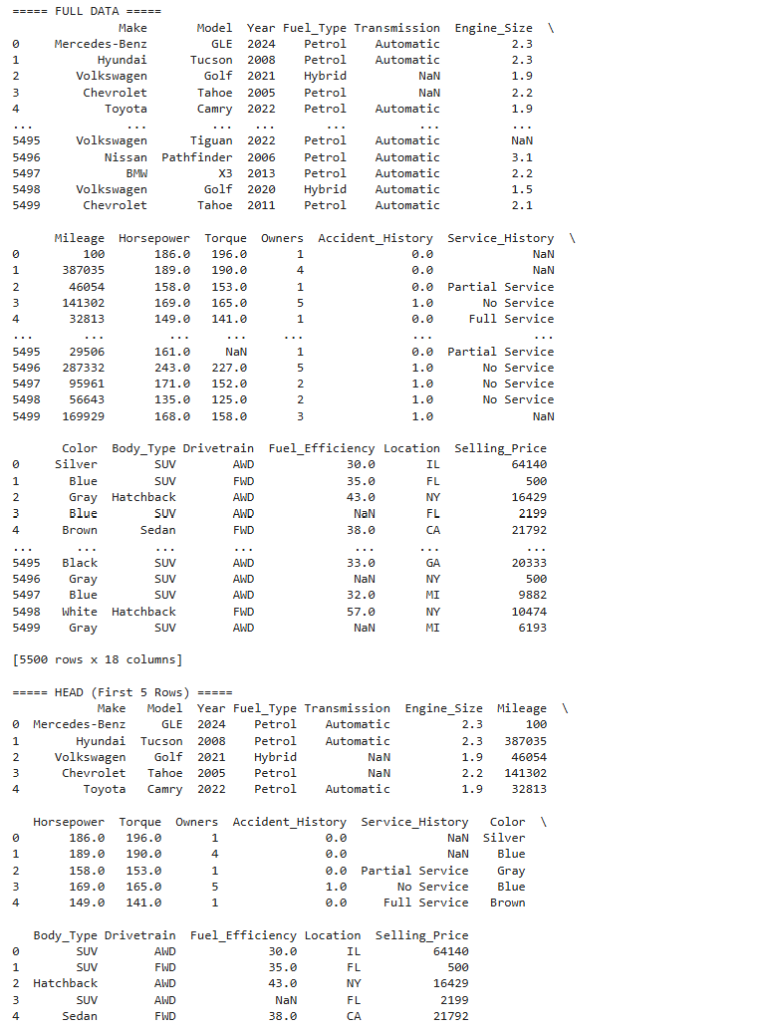
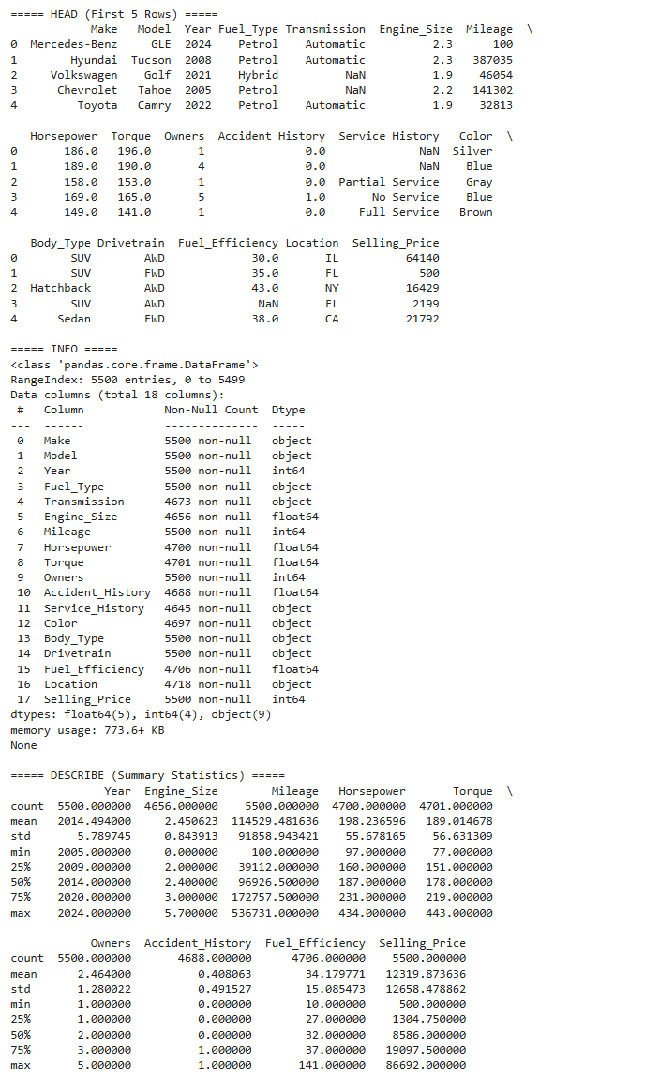
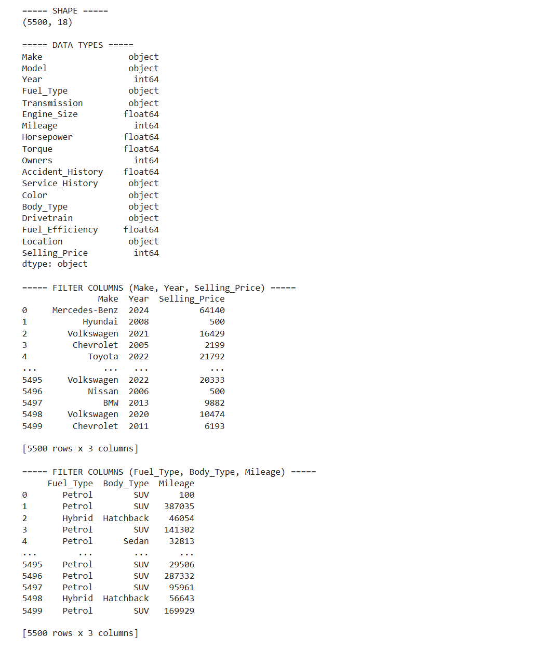
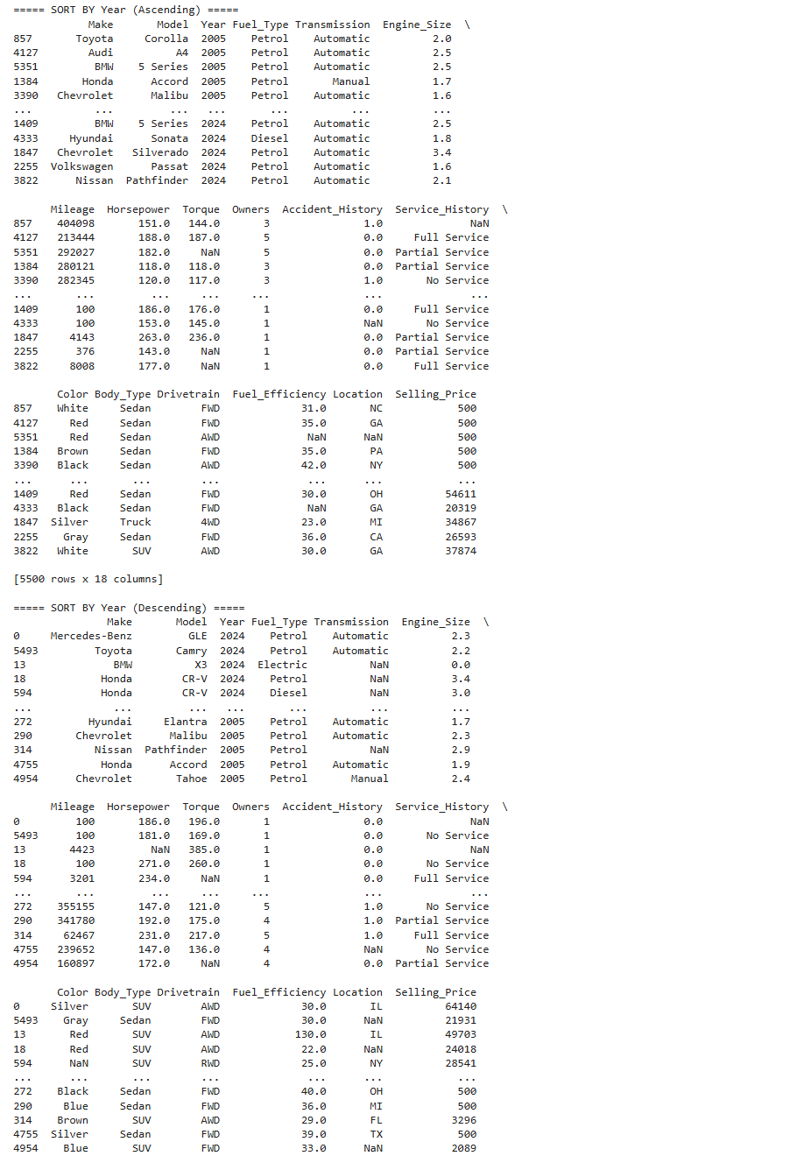
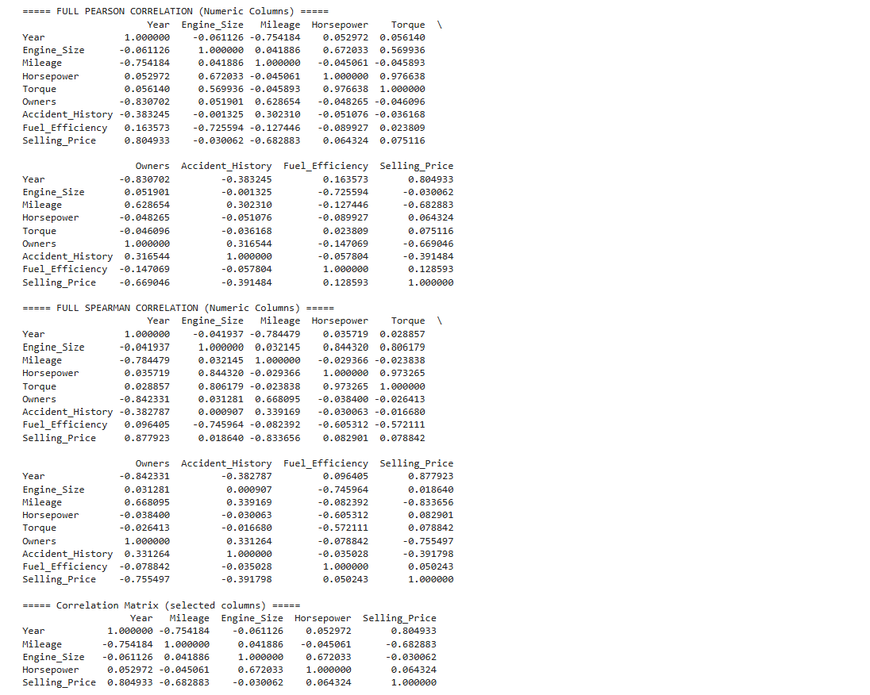
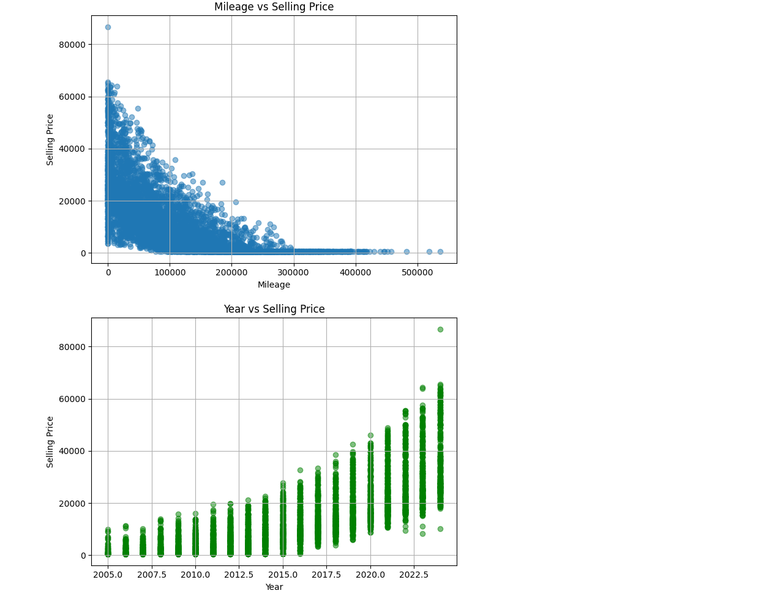
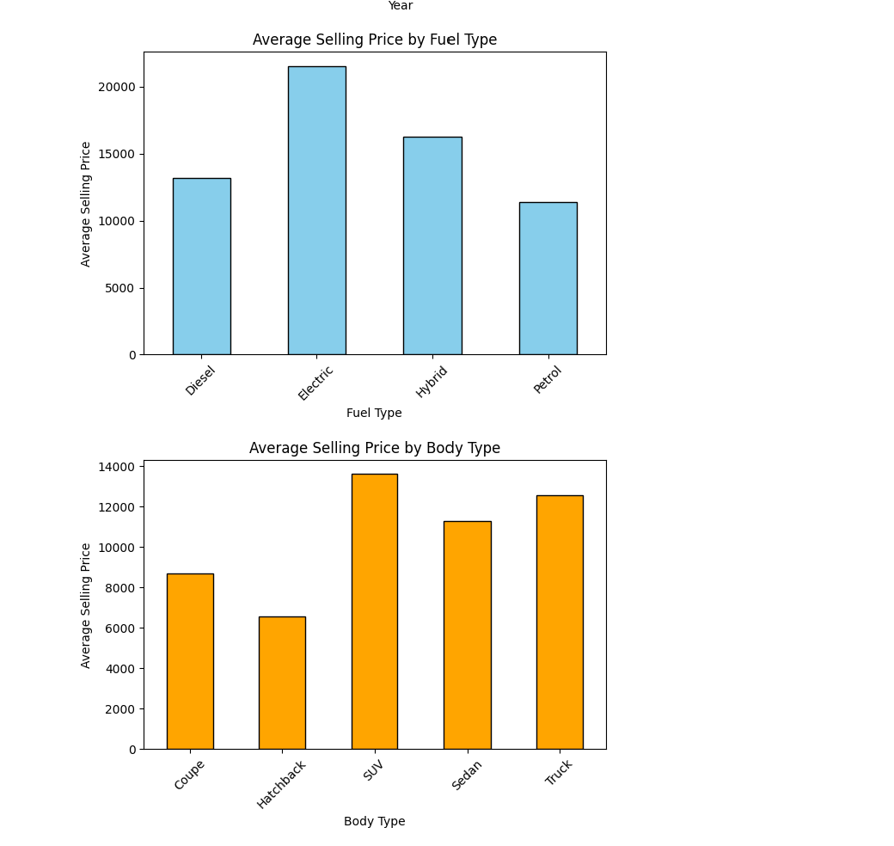

Result:

